# Lab 4 plus

*Lab 4 plus is a combination of Lab 4 and an extra activity on ARP.

# Packet Tracer Simulation – Exploration of ARP and Switch Table Communications

**Objectives**

* To explore ARP and switching operations.

**Introduction**

The topology is given to you. All IP addresses have been assigned to all devices. Please follow each step in sequence.

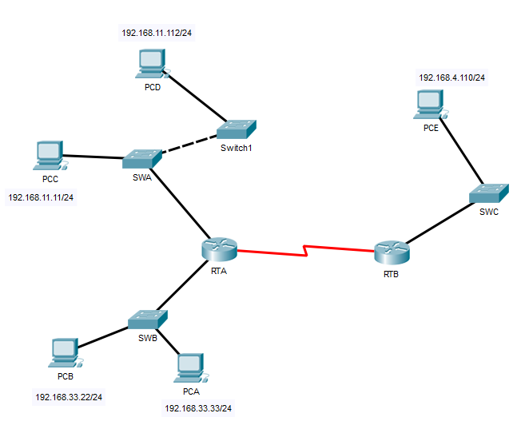

Figure 1

**Part 1: Review the topology**

**Step 1:** Perform the following tasks.

1. At Router RTA, enter the CLI. At the command prompt type the following commands. Snap the results after the last command and paste it here.

|  |
| --- |
| RTA>enable  RTA#show arp |

1. At Router RTB, enter the CLI. At the command prompt type the commands as in Figure 2. Snap the results after the last command and paste it here.
2. At Switches SWA, SWAB and SWC, enter the CLI. At the command prompt type the following commands. Snap the results after the last command and paste it here.

|  |
| --- |
| SWA>enable  SWA#show arp  SWA#show mac-address-table |

1. At PCA, click on the PC icon, and then choose Desktop-Command Prompt. At the command prompt type **arp –a** and click enter. Snap the results after the last command and paste it here. Do this to all PCs in the topology.
2. What are your thoughts on the results?

**Part 2: Generate Network Traffic**

**Step 1: Generate traffic between PCA and PCB.**

In the command prompt Perform the following tasks task to reduce the amount of network traffic viewed in the simulation.

1. Click **PCA** and click the Desktop tab > Command Prompt.
2. Enter the **ping 192.168.33.22** command. This may take a few seconds.
3. In the Command prompt of PCA, type **arp –a**. Paste the result of this command here.
4. In the Command prompt of PCB, type **arp –a**. Paste the result of this command here
5. In the Command prompt of PCC, PCD abd PCE, type **arp –a**. Paste the result of this command here.

**Step 2: Generate traffic between PCC to all other PC except PCA.**

1. Click **PCC** and click the Desktop tab > Command Prompt.
2. Enter the **ping 192.168.33.22** command (ping to PCB). Then type **arp –a**. Paste the result after these commands here.
3. Enter the **ping 192.168.11.112** command (ping to PCD). Then type **arp –a**. Paste the result after these commands here.
4. Enter the **ping 192.168.4.110** command (ping to PCE). Then type **arp –a**. Paste the result after these commands here.
5. Discuss the results you got from all the commands on PCC.
6. At Router RTA, enter the CLI. At the command prompt type the following commands. Snap the results after the last command and paste it here.

|  |
| --- |
| RTA>***enable***  RTA#***show arp*** |

1. At Router RTA, enter the CLI. At the command prompt type the following commands. Snap the results after the last command and paste it here.

|  |
| --- |
| RTB>***enable***  RTB#***show arp*** |

**Step 3: Switch MAC address table.**

1. At Switch SWA, enter the CLI. At the command prompt type the following commands. Snap the results after the last command and paste it here.

|  |
| --- |
| SWA>***enable***  SWA#***show arp***  SWA#***show mac-address-table*** |

1. At Switch SWB, enter the CLI. At the command prompt type the following commands. Snap the results after the last command and paste it here.

|  |
| --- |
| SWB>***enable***  SWB#***show arp***  SWB#***show mac-address-table*** |

1. At Switches SWC and Switch1, enter the CLI. At the command prompt type the following commands. Snap the results after the last command and paste it here.

|  |
| --- |
| SWC>***enable***  SWC#***show arp***  SWC#***show mac-address-table*** |

1. Do switches use arp table? (Y/N)
2. Explain your answer in (d) *\*Hint: the answer may surprise you. Google for the explanation. It is not part of NetComm syllabi, it is just for knowledge..*
3. What information does the command ***show mac-address-table*** gives?

**Part 3: Attach wireless lab results.**

In this part, you will use Lab 4 .pka file.

**Step1: Change the filename of Lab 4.**

1. Change the Lab 4 filename to include your name. *\*Example: Lab4AliAhmad.pkt*
2. Go through the instructions. As you complete the tasks, you will see the bottom right hand corner of the pkt file increase in completion percentage, until you get 100/100.

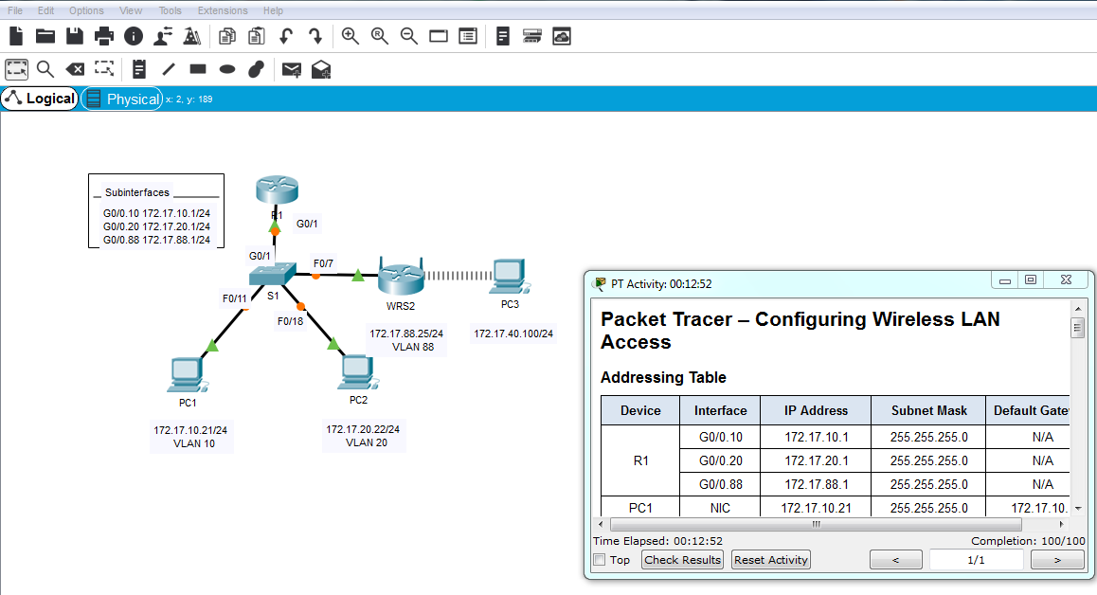

1. Once you have completed fully, capture the screen (which includes the filename, the topology and the activity wizard showing completion) and paste it here.